Chapter 6
IoT Application Design

M2M is a system that allows machines to communicate with each other and with humans. It is an extension of the Internet of Things (IoT) that allows for easier and more direct access to the data and functionality of connected devices. M2M is a standardized technology for managing and sharing the data and functionality of connected devices. It is used in applications such as metering, automation, tracking and tracing, healthcare, and many others.
Machine-to-machine (M2M) communication is the exchange of information between machines. M2M is a network of physical objects capable of capturing information about their state, communicating that information over a network without requiring human interference, and using that information to control their operational behavior. The most prevalent form of M2M communication is data exchange between objects in a utility metering context, such as smart electric meters in homes and businesses.

What is the Primary Purpose of M2M?
The primary purpose of Machine to Machine communications is to enable machine-to-machine (M2M) interaction, which has been proposed as a specialized application of the Internet of Things (IoT). M2M communications allow for smart objects to communicate with each other without the intervention of humans. For example, smart meters are independent devices that measure electrical power consumption in real-time and communicate it wirelessly to the electric utility. A system of smart meters can provide the utility company with near-instantaneous information about power demands for a large area.
M2M communications is a rapidly developing technology, and it is expected to have a wide range of both immediate and long-term impacts on all areas of life. M2M communications are especially promising in the area of industry where there is an increasing demand for a more efficient, less expensive, and faster technology. It is anticipated that the use of M2M communications will decrease cost, time, and energy consumption. It can also increase safety, reliability, and quality.

Key Difference: IoT Vs M2M
The Internet of things (IoT) is the network of physical devices, vehicles, home appliances, and others embedded with electronics, software, sensors, actuators, and connectivity which enables these things to connect and exchange data, creating opportunities for more immediate integration between the physical world and computer-based systems. With regard to M2M (machine to machine) communication, there are several differences. The M2M communications are used to connect machines to machines within the same cellular network. The IoT is used to connect machines to machines across different cellular networks.

Differences Between IoT and M2M
Basis | IoT | M2M
Abbreviation | Internet of Things | Machine to Machine
Communication | IoT sensors automation | Communicates directly between machines
Connection | The connection is via using various communication types | Point to Point Connection
Communication protocols | HTTP, Ftp, Telnet, etc are used | Communication technology techniques and traditional protocols are used.
Intelligence | Objects are responsible for decision making | Observation of some degree of intelligence
Technology | Hardware and Software based technology | Hardware-based technology
Data Delivery | Depending on the Internet protocol | Devices can be connected through mobile or other networks
Internet Connection | Active Internet connection is required | Devices do not rely on an internet connection
Scope | Many users can connect at a time over the Internet | Communicate with a single machine at a time
Business Type | B2C(Business to Customers) and B2B(Business to Business) | Only B2B(Business to Business) is used
Open API support | IoT supports open API Integrations | M2M does not support open API
Data Sharing | Data is shared with applications that tend to improve the end-user experience | Data is shared with the communication parties themselves.

https://www.interviewbit.com/blog/difference-between-iot-and-m2m/

THINGS TO KEEP IN MIND WHILE BUILDING AN IOT PROTOTYPE
If you’re ready with your idea and want to work on your IoT prototype, here are some things that you should keep in mind-
- Get the toughest problem out of the way first. It’s very important to start with the riskiest assumption when prototyping your IoT product. This will force you to make major product decisions early in the stage rather than months into the development cycle when you would’ve spent your time and resources developing a product that doesn’t fulfill your requirement.
- Second, decide on which technologies you’re going to use in developing the IoT Solution. This may include a lot of research and some hits and trials. You might even run into some dead ends but by the end, you’ll be sure which technologies and communication protocols are best suited for your IoT product.
- Once that is out of the way, it’s time to start building and finding solutions for the hiccups encountered in the process.
Full Stack IoT Product Development consists of various stages and is a long journey till Product Development.
The first step is PoC in which the development team finds out the viability of the solution required and what challenges could possibly come on the way to Product Development. This is usually done within a few days of the start of the project. This provides a rapid analysis of the required IoT solution.
After PoC, a prototype is created with hardware and software elements. A prototype is something that can be handed over to the client for demonstration. It basically shows the system simulation and helps in finding out the usability of the product. It generally takes weeks of time.
When the usability of the product is checked, it is time to find out the market demand for the product. A basic version of the solution is launched, which helps in getting user feedback at the preliminary level. This takes at least a few months to get an IoT solution at this level.
Now it is the time to end the development journey and launch the final product.
Although IoT Solution involves various stages, prototyping is one such stage. Even IoT prototyping consists of different versions and is upgraded at levels.

APPEARANCE MODEL in IoT prototype
An appearance model is a physical mock-up, first, it is a series of drawings that explore the number of configurations for the product. Then a 3D structure is printed which helps in forecasting the look of the end product. The dimensions are not frozen at this stage but are kept in mind as a target size. The appearance model is used to demonstrate the size, color, control locations, actuator location, etc., and to give the investor a visual idea of the product.

IOT PROOF OF CONCEPT
To evaluate the performance of a subsystem or technical component for feasibility Proof of concept (PoC) prototypes are used. It is the quickest way to evaluate the viability of the user interface. The main purpose is to prove if your theory actually works in practice or not. PoC is 40%-80% stable and should be done within a few months. This is done on the development boards and modules, connecting everything with jumping wires. This is also one of the ways to do Rapid Prototyping.

Alpha Phase in iot Prototyping
The Alpha prototype is the initial attempt made to design the prototype according to the requirements listed in the Product Requirements Specification (PRS). It is also the first attempt at making it look and work as close as possible to the final product. The iterative process used for building this prototype can provide guidance for the upcoming stages of development. The Alpha Development is more expensive as compared to the previous stages and requires more time as well. The Alpha stage is important to understand the limitations of the product so that you can take time to refine them.

Beta phase in Iot prototyping
Design refinements found in the Alpha stage are incorporated in the Beta stage. Software is refined and is prepared for final testing and initial release. The documentation is updated accordingly. Test plans and verification tools are made and the prototypes are ready for preliminary validation testing, and safety and performance testing in compliance with the PRS. Beta prototypes overcome any deficiencies in meeting the standards.

Pilot production of an Iot project
Refinements from the Beta stage are incorporated into the design and implemented in the pilot production phase. The design is submitted to the manufacturing team and units are produced for summative usability testing and clinical trials. After that, some units are released onto the market. The design and production process are relatively stable.

Matured Product
The matured product takes into account the refinements that are to be made from user feedback and production monitoring. This stage has a high yield, the design and assembly process are stable and cost-saving methods are incorporated.
https://psiborg.in/what-is-iot-prototyping-and-why-it-is-required/

Prototyping for m2m – not available

The concept of Home Automation aims to bring the control of operating your every day home electrical appliances to the tip of your finger, thus giving user affordable lighting solutions, better energy conservation with optimum use of energy. Apart from just lighting solutions, the concept also further extends to have a overall control over your home security as well as build a centralised home entertainment system and much more. The Internet of Things (or commonly referred to as IoT) based Home Automation system, as the name suggests aims to control all the devices of your smart home through internet protocols or cloud based computing.
The IoT based Home Automation system offer a lot of flexibility over the wired systems s it comes with various advantages like ease-of-use, ease-of-installation, avoid complexity of running through wires or loose electrical connections, easy fault detection and triggering and above and all it even offers easy mobility.
Thus IoT based Home Automation system consist of a servers and sensors. These servers are remote servers located on Internet which help you to manage and process the data without the need of personalised computers. The internet based servers can be configured to control and monitor multiple sensors installed at the desired location.
Let us understand in detail the working of different smart devices which together constitute the Home Automation system.
Controller: The Brain of Your System
The main controller or the hub is the most essential part of your Home Automation system irrespective of whether you connect single or multiple sensors in your home. The main controller or the hub is also referred to as gateway and is connected to your home router through the Ethernet cable. All the IoT based sensors transmits or receive commands through the centralised hub. The hub in turn receives the input or communicates the output to cloud network located over the internet.
Due to this kind of architecture, it is possible to communicate with the centralised hub even from remote and distant locations through your smartphone. All you need is just a reliable internet connection at the hub location and the data package to your smartphone that helps you connect to the cloud network.
Most of the smart home controllers available in the market from several manufacturers cater to all three widely used protocols of wireless communication for Home Automation: ZigBee, Z-Wave and Wi-Fi.
Smart Devices: The Sensory Organs of Your Home
The IoT based home automation consist of several smart devices for different applications of lighting, security, home entertainment etc. All these devices are integrated over a common network established by gateway and connected in a mesh network. This means that it gives users the flexibility to operate one sensor based followed by the action of the other. For e.g. you can schedule to trigger the living room lights as soon as the door/windows sensor of your main door triggers after 7pm in the evening.
Thus all the sensors within a common network can perform cross-talk via the main controller unit. As shown in the figure, some of the smart sensors in home automation acts as sensor hubs. These are basically the signal repeaters of signal bouncers which that are located in the midway between the hub installation location and the sensors that are at a distant location. For such long distances, these sensor hubs play an important role to allow easy transmission of signals to sensors that are far away from the main controller but in closer proximity to the sensor hub. The commonly used sensor hubs in IoT based Home Automation system are Smart Plugs.
Wireless Connectivity: How the Internal Communication Occurs
Most of the IoT based Home Automation systems available today work on three widely used wireless communication protocols : Wi-Fi, ZigBee and Z-Wave
The ZigBee and the Z-Wave controllers are assigned a network ID which is distributed over other sensors in the network. The communication amongst devices take place in a mesh topology where there is no fixed path for the signals transmitted from the controller to the sensors and vice versa. Depending on the availability of the shortest path the signal from the controller will travel to the target sensors either directly or through signal hops. If any intermediate sensor in the pathway is busy or occupied the signal will trace another path within the mesh network to reach the final destination. Note that sensors with different Network IDs cannot communicate with each other over common channel.
Wi-Fi: Please explain this section.
Connected with the Cloud: Access Everything on the Go
The Cloud-based-Networking system involves storage and maintenance of data over the Internet location. This gives users the flexibility to have access to the data from any location on the planet.
As a result of this, in IoT based Home Automation systems users over the cloud network can send commands to the hub even from a distant or remote location. The hub will further send the signal for the intended sensors to trigger and perform the user-requested action. Once the action is performed, the hub will update the status of the action taken to the cloud network and in this way users can control and monitor every aspect of their smart homes.
Events and Notifications: Get Notified Instantly
Real-time monitoring and notifications is one of the key features of IoT based Home Automation systems. Since the hub is connected over the cloud network through the Internet, you can schedule various events as per your routine activities or daily schedules. The cloud network can receive and store all the user inputs and transfer them to the hub as per the scheduled events.
Once the hub transfer the desired signals to the target sensor and the desired action takes places, it will quickly upload the new status over the cloud notifying user instantaneously. For e.g. the motion sensor will instantaneously notify the user wither through emails, SMS, calls or App notifications when it detects any unwanted motion or intrusion. After receiving such notification, the user can quickly turn on the IP based home security smart camera can check the status of your home even from remote location.
https://smartify.in/knowledgebase/iot-based-home-automation-system/

Overview :

- Home automation is constructing automation for a domestic, mentioned as a sensible home or smart house. In the IoT home automation ecosystem, you can control your devices like light, fan, TV, etc.
- A domestic automation system can monitor and/or manage home attributes adore lighting, climate, enjoyment systems, and appliances. It is very helpful to control your home devices.
- It’s going to in addition incorporates domestic security such as access management and alarm systems. Once it coupled with the internet, domestic gadgets are a very important constituent of the Internet of Things.
- A domestic automation system usually connects controlled devices to a central hub or gateway.
- The program for control of the system makes use of both wall-mounted terminals, tablet or desktop computers, a smartphone ​application, or an online interface that may even be approachable off-site through the Internet.
- Smart Home automation refers to the use of technology to control and automate various functions in a home, such as lighting, heating, air conditioning, and security. In the context of IoT (Internet
of Things) and M2M (Machine-to-Machine) communications, home automation systems can be controlled and monitored remotely through a network connection.
- One of the key benefits of IoT-enabled home automation is the ability to control and monitor a wide range of devices and systems from a single, centralized location, such as a smartphone or tablet. This can include everything from lighting and temperature control to security cameras and alarm systems.
- Another advantage of IoT-enabled home automation is the ability to remotely monitor and control devices, even when away from home. This can be useful for controlling energy consumption and ensuring the safety and security of the home.
- IoT-enabled home automation systems typically involve the use of smart devices, such as thermostats, light bulbs, and security cameras, that can be controlled and monitored through a centralized hub or app. These smart devices can communicate with each other and with the centralized hub using wireless protocols such as Zigbee, Z-Wave, and Bluetooth.
- In addition, IoT-enabled home automation systems can integrate with other smart home technologies, such as voice assistants like Alexa and Google Home, to provide additional functionality and convenience.
- Overall, IoT-enabled home automation can provide many benefits to homeowners, including increased convenience, energy efficiency, and security. However, it is important to ensure the security of these systems, as they may be vulnerable to hacking and other cyber threats.

Components :
Here, you will see the smart home components like smart lighting, smart appliances, intrusion detection, smoke/gas detector, etc. So, let’s discuss it.
Component-1 :
Smart Lighting –
- Smart lighting for home helps in saving energy by adapting the life to the ambient condition and switching on/off or dimming the light when needed.
- Smart lighting solutions for homes achieve energy saving by sensing the human movements and their environments and controlling the lights accordingly.
Component-2 :
Smart Appliances –
- Smart appliances with the management are here and also provide status information to the users remotely.
- Smart washer/dryer can be controlled remotely and notify when the washing and drying are complete.
- Smart refrigerators can keep track of the item store and send updates to the users when an item is low on stock.
Component-3 :
Intrusion Detection –
- Home intrusion detection systems use security cameras and sensors to detect intrusion and raise alerts.
- Alert can we inform of an SMS or an email sent to the user.
- Advanced systems can even send detailed alerts such as an image shoot or short video clips.
Component-4 :
Smoke/gas detectors –
- Smoke detectors are installed in homes and buildings to detect smoke that is typically an early sign of Fire.
- It uses optical detection, ionization for Air sampling techniques to detect smoke.
- Gas detectors can detect the presence of harmful gases such as CO, LPG, etc.
- It can raise alerts in the human voice describing where the problem is.
https://www.geeksforgeeks.org/iot-home-automation/

Smart parking system using IoT has smartphones and other sensors added into an interconnected system to determine parking space or level and provide real-time feedback. It is accomplished by using cameras, counters on the doors or gates of parking lots, sensors embedded in the paved area of ​​individual parking lots, among other locations, depending on the deployment.

Solutions using IoT-based parking
IoT-based smart parking system transmits available and occupied parking spaces via a web/mobile application.
Each parking space has an IoT gadget, which includes sensors and microcontrollers. The user gets real-time updates on the availability of all parking spaces and, therefore, an option to choose the best one. This solution alone initiates a chain-reaction of benefits, from lesser traffic congestion to reduced fuel efficiency, in urban areas where parking is often painstaking.
A basic flowchart for the whole process of smart parking IoT looks like this:
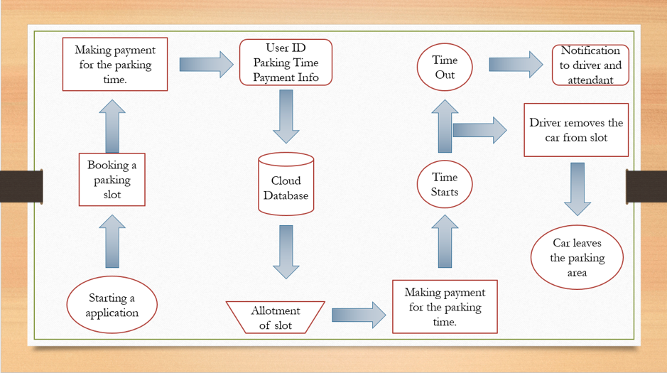

Architecture of Smart Parking System
It consists of the following components:
- Parking Sensors
The role of the parking sensors is to track space in the parking lot. Ultrasonic sensors are used to detect the presence of vehicles.
- Processing Unit
The processor-on-a-chip acts as a central point between the sensors and the cloud platforms, relaying data to and from.
- Mobile Application
It is a visual interface for end-users to interact with the smart parking system.
- The Cloud
The cloud serves as a repository for all records related to parking spaces and end-users who have access to the system.
The deployment of smart parking systems is expected to increase thanks to the rising issue of parking and reducing costs of implementing a smart parking system.
Another innovation is using visual image processing to capture a vehicle license number to identify it with the help of Optical Character Recognition technology. It then automatically opens the gate in the parking lot, and the system directs the driver to the appropriate parking lot.
The future looks very promising for smart parking systems. The technologies behind this solution are IoT, artificial intelligence, machine learning, and augmented reality. By using these new approaches, smart parking will increase the efficiency of parking systems.

Applications of Smart Parking Systems using IoT
Smart cities offer better use of space, less traffic, clean air, and more efficient public services, increasing the quality of life. In addition, smart cities provide many jobs and economic opportunities, and strong social connections.
Smart parking IoT project will help in:
- The seamless flowing of traffic
Public transport routes can be adjusted in real-time according to need, and smart traffic lights systems can improve congestion.
- Energy efficiency can be improved
One can easily track down the power consumption & energy consumption by monitoring in real-time.
- Cities can be made safer
Cities can use technology to improve residents’ safety and improve response times with the widespread use of Wi-Fi communications and IoT technology.
- Encouragement of greater citizen engagement
Citizens can respond to daily problems enabling neighbors to connect and share resources to improve communities and neighborhoods.

How IoT can be used in parking management
The rapid demand for parking spaces stems from two major trends – urbanization and car ownership. In a short period, the IoT-based parking management system has positively impacted all stakeholders involved in the process.
For instance, drivers can plan trips and commutes keeping slot occupancy in mind. Enforcement agencies can detect and evaluate the gravity of parking rules violations in seconds.
Parking facility managers can optimize the use of the personnel and the available space. Adding to that thought, IoT can be used in parking management in the following ways:
- Create “smart” parking meters that accept payments via credit card or smartphone and provide real-time information on space availability.
- Extend the operating time of an autonomous parking system by consuming less power with the help of LoRaWAN® networking standard.
- Send real-time data from IoT sensors to a cloud server and share it with users to provide them with the details of free-parking spaces.
- Determine the number and position of vacant parking spaces precisely using IoT sensors.
- Reduce congestion and improve traffic flow by using sensors to monitor parking space availability and direct drivers to available spaces.
- IoT gateway and the LPWAN protocol help connect IoT devices and sensors in sizable parking lots.
- The parking management company can use a cloud-based IoT dashboard. It uses gathered sensor data to mine intelligible insights that are visually appealing and provides a clear picture of the parking facility.
- Optimize parking operations and improve security by tracking vehicles entering and exiting a parking facility.
- Mobile applications can display parking data to drivers and send alerts in case of a security breach.
- Monitor environmental conditions in parking garages, such as air quality and temperature, to ensure the safety of occupants.

IoT-based sensing devices commonly used for smart parking systems include:
- Ultrasonic sensors measure the distance of a target object by eliminating ultrasonic sound waves and convert the reflected sound into an electrical signal.
- Electromagnetic field detection is helpful to detect metals as they pick up minute changes in the magnetic field.
- Infrared sensors can detect motion and gauge temperature changes in the immediate surroundings.

Technical challenges

1. Correctness of information
A key challenge is ensuring correct information is displayed to the users on the application at all times. Inaccuracy or delays in receiving the data may result in drivers traveling to different places than the designated parking spots - causing much mayhem and confusion on the roads.

2. Availability of standard IoT tools
The service providers use technological platforms like the P&E PARC and PUCRS to manage the parking process which is so extensive. These include computer clients, servers, wireless and wired telecommunications systems, hardware sensors, dynamic messaging systems, traffic management devices, and application interfaces.
The biggest obstacle to lowering the price and complexity of IoT smart parking is making it possible for all these devices from hundreds of different vendors to speak with one another and connect to a single platform.
Another problem with installing a smart parking management system is requiring numerous sensors to be online to obtain data for a single booking window. You must have a variety of routers, which looks to be a challenge.
However, because of the mesh connection, all the sensors are internally connected and can function independently, even when not online. As a result, only one sensor is linked to the internet and transmits data to all other sensors. Since other routers do not require an internet connection, it performs well. Still, it is not the most reliable solution.

3. Lack of talent in the smart technology space
Automated parking management systems will require professionals who are familiar with IoT and can provide immediate troubleshooting. Deploying such intricate smart solutions requires the finest advice for carrying out the projects correctly.
Awareness and acceptance
It is an enormous undertaking to transform a culture that has existed for many centuries. Parking has always been a current business involving direct financial exchange. The incorporation of technology represents a cultural shift that will take some time.

High cost of implementation
The capital investment required to install smart parking infrastructure can be very high. For example, a single parking space can cost upwards of $1,000 to equip with the necessary sensors and IoT devices. When you multiply that by the number of parking spaces in a given facility, the costs can become prohibitive.
https://www.intuz.com/blog/iot-in-smart-parking-management-benefits-challenges

What is an IoT based weather monitoring system?
It is a system that involves in acquiring weather and environment data using advanced electronic sensors and sending them to a web server via internet for real time weather monitoring and storage of data for future analysis and study.
Why we need an IoT based weather monitoring system?
- Ease of monitoring your local weather conditions in real time from anywhere in the world.
- For storing weather and environment data for short and long term for studying weather pattern changes and to understand how human induced climate change affected your local weather.
- Easy deployment of the setup for monitoring local atmospheric conditions and microclimates for weather forecasting and prediction.
Types of sensors involved in weather monitoring:
We can find wide spectrum of electronic sensors involved in weather monitoring system depending on the kind of application.
Farmers need to know the temperature, relative humidity, soil moisture, rain fall etc. to enhance their crop production and the following type of sensors are utilized to obtain the data:
- Temperature sensor.
- Humidity / hygrometer sensor.
- Soil moisture sensor.
- Rain sensor etc.
For an airplane pilot he/she needs to know wind speed, wind direction, atmospheric pressure, precipitation, visibility etc. before they takeoff and they use the following sensors:
- Barometric sensor – for measuring atmospheric pressure.
- Anemometer – for measuring wind speed.
- Rain sensor.
- Visibility sensor – for measuring visibility during snow, rain, storm etc.
In conclusion, the sensors used for monitoring weather depends on the type application we going to deploy for.
We are going to develop the weather monitoring system using the above illustrated blocks. The brain of the project is an Arduino board and the surrounding blocks are digital and analog sensors for acquiring local weather and environment data.
A generic ESP8266 is used for interfacing the circuit setup with internet via 2.4 GHz Wi-Fi band. The ESP8266 sends the sensor data to a cloud server where the data gets updated in real time and also gets stored for future analysis. We are utilizing a 16 x 2 LCD display to showcase the sensor data, so that we can observe real-time data locally.
The above circuit consists of the following modules:
- 5V / 3.3V Power supply regulator.
- Arduino Uno.
- 16 x 2 display with I2C adapter module.
- DHT11 temperature & humidity sensor.
- MQ-135 sensor air quality sensor.
- BMP180 – Barometric sensor.
- Light depend resistor (LDR).
- Generic ESP8266 Wi-Fi module.
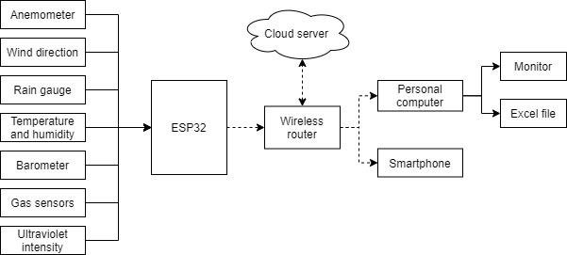
https://electronics-project-hub.com/iot-based-weather-monitoring-system-using-arduino/

https://www.researchgate.net/figure/System-block-diagram-of-the-weather-station_fig1_354597278

The IoT-based air pollution monitoring system is created using sensors and microcontrollers that gathers all the relevant data regarding air quality. Users can access all the related information in real-time. This sensor-based technology benefits occupants in a number of ways:
- Effective air monitoring
Installing advanced sensors in the required locations of a building helps in detecting the presence of particulate matter or pollutants in the air. They work automatically and send notifications on smartphones at once. Based on the gathered information, facility managers can analyze the situation, monitor the air quality, and act accordingly.
With an IoT-based air quality monitoring system, they will never miss out on anything and keep the surroundings fresh all the time.
2. Detection of toxic gases
The presence of toxic gases in an environment can lead to disastrous consequences and severely impact the health of the occupants. IoT-powered air quality monitoring system is an advanced technology that detects these toxic gases within the premises quickly. All thanks to its advanced sensor devices and gateway connectivity!
Building owners get complete control over the IoT solution that allows them to take appropriate actions against the discrepancies happening because of air quality. In this way, the chances of gas explosions, fire hazards, and other naturally occurring calamities are automatically reduced. What’s the plus point? Facilities can also reduce operational costs and ensure preventive maintenance of assets.
3. Temperature and humidity measurement
Temperature monitoring in a building plays a vital role in stabilizing indoor air quality. It helps authorities to maintain an ideal room temperature and proper ambiance under certain environmental conditions. The IoT-powered solution gives rise to this technology.
With temperature and humidity monitoring, facilities can maintain a favorable environment in a building. This technology is specifically useful in the mining industries where maintaining an appropriate level of oxygen is necessary. The air quality monitoring system keeps employees safe in mining industries by detecting the decreasing oxygen levels and allowing them to evacuate the premises as soon as possible.
4. Ensures better environmental conditions
The quality of life depends on the quality of air. Remote monitoring IoT systems ensure better air quality, reduce cost, increase coverage, and provide more flexibility to occupants. It results in better environmental conditions for humans to reside in.
5. Better human health
IoT-powered solutions are capable enough to monitor the presence of pollutants that reduces the chances of any health issues by maintaining a moderate ambiance or as required. It even provides better services to its customers and helps in the formation of a smart building.
Facilities can create a positive impact on human health by eliminating unwanted air pollutants and particulate matter with the application of this advanced technology.
6. Meet air quality standards
The air quality index provides the building managers with timely and easy-to-understand information on local air quality. It also gives insights into air pollution levels used by EPA and other agencies.
IoT-based air quality monitoring systems help in determining if an area is meeting the air quality standards devised by CPCB, WHO, or not.
https://www.zenatix.com/6-benefits-of-iot-based-ambient-air-quality-monitoring-system/

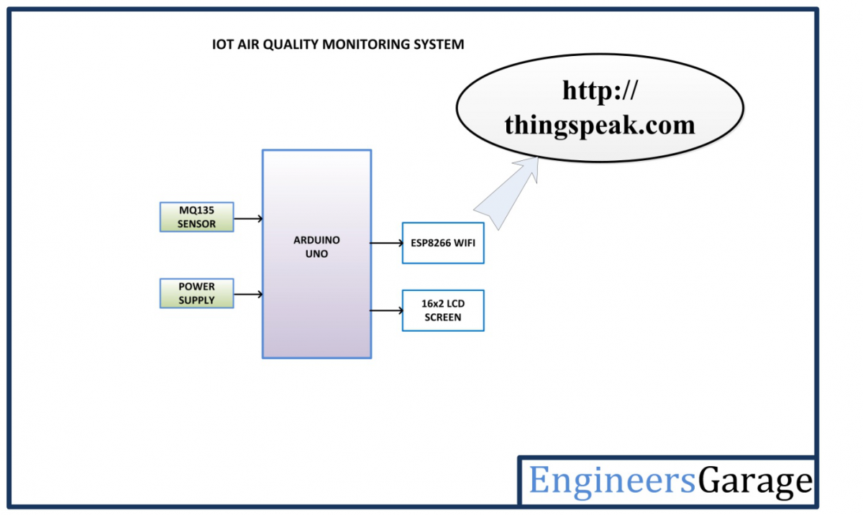

The air pollution monitoring device developed in this project is based Arduino UNO. The Arduino board connects with ThingSpeak platform using ESP8266 Wi-Fi Module. As the cities usually have Wi-Fi hotspots at most of the places, so the device can be easily installed near any hotspot for its operation. The ThingSpeak is a popular IOT platform which is easy to use and program. The sensor used for monitoring the air pollution is MQ-135 gas sensor. The sensor data is also displayed on a character LCD interfaced in the monitoring IOT device.
The sensing of data and sending it to the ThingSpeak server using Wi-Fi module is managed by the Arduino Sketch. The Arduino sketch is written, compiled and loaded to the Arduino board using Arduino IDE

How the circuit works –

The device developed in this project can be installed near any Wi-Fi hotspot in a populated urban area. As the device is powered, the Arduino board loads the required libraries, flashes some initial messages on the LCD screen and start sensing data from the MQ-135 sensor. The sensitivity curve of the sensor for different combustible gases is already mentioned above. The sensor can be calibrated so that its analog output voltage is proportional to the concentration of polluting gases in PPM. The analog voltage sensed at the pin A0 of the Arduino is converted to a digital value by using the in-built ADC channel of the Arduino. The Arduino board has 10-bit ADC channels, so the digitized value ranges from 0 to 1023. The digitized value can be assumed proportional to the concentration of gases in PPM. The read value is first displayed on LCD screen and passed to the ESP8266 module wrapped in proper string through virtual serial function. The Wi-Fi module is configured to connect with the ThingSpeak IOT platform. ThingSpeak is an IOT analytics platform service that allows to aggregate, visualize and analyze live data streams in the cloud. ThingSpeak provides instant visualizations of data posted by the IOT devices to ThingSpeak server. With the ability to execute MATLAB code in ThingSpeak one can perform online analysis and processing of the data as it comes in.

https://www.engineersgarage.com/arduino-based-air-quality-monitoring-iot-project/

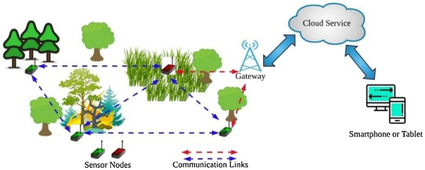

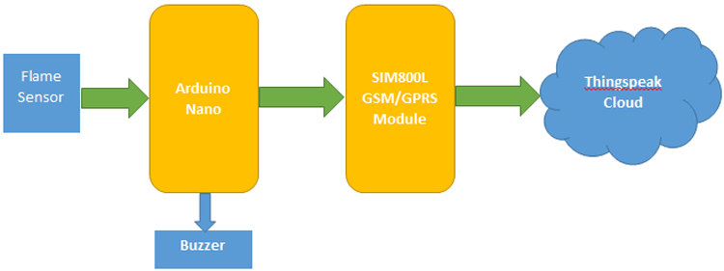

Arduino compares the signal and triggers the SIM800L in case of fire incidents. Through AT commands, SIM800L communicates with thingspeak server.

https://circuitdigest.com/microcontroller-projects/iot-based-forest-fire-detection-using-arduino-and-gsm-module

Most of the farmers use large portions of farming land and it becomes very difficult to reach and track each corner of large lands. Sometime there is a possibility of uneven water sprinkles. This result in the bad quality crops which further leads to financial losses. In this scenario the Smart Irrigation System using Latest IoT technology is helpful and leads to ease of farming.
The Smart irrigation System has wide scope to automate the complete irrigation system. Here we are building a IoT based Irrigation System using ESP8266 NodeMCU Module and DHT11 Sensor. It will not only automatically irrigate the water based on the moisture level in the soil but also send the Data to ThingSpeak Server to keep track of the land condition. The System will consist a water pump which will be used to sprinkle water on the land depending upon the land environmental condition such as Moisture, Temperature and Humidity.
Before starting, it is important to note that the different crops require different Soil Moisture, Temperature and Humidity Condition. So in this tutorial we are using such a crop which will require a soil moisture of about 50-55%. So when the soil loses its moisture to less than 50% then Motor pump will turn on automatically to sprinkle the water and it will continue to sprinkle the water until the moisture goes upto 55% and after that the pump will be turned off. The sensor data will be sent to ThingSpeak Server in defined interval of time so that it can be monitored from anywhere in the world.

Components Required
- NodeMCU ESP8266
- Soil Moisture Sensor Module
- Water Pump Module
- Relay Module
- DHT11
- Connecting Wires
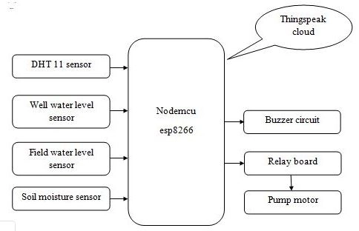

https://circuitdigest.com/microcontroller-projects/iot-based-smart-irrigation-system-using-esp8266-and-soil-moisture-sensor

13Fig.4 depicts the general schematic for the proposed system. The library will have QR scanners for verification of the users and borrowing/returning. The QR code of each user’s phone helps in easy retrieval of information. The entire hardware setup is connected to the local area network in the library. The shelf monitors use radio frequency identification and have LCD display to show the exact position of books and help the users locate them easily as these are inter-connected with library software. Internet of things will allow easy accessibility to library shelves which have rack controlling device consisting of monitors and sensors. The database has separate tables for each of the Rack Monitors. This will help solve the problem of misplacing of books. The alarms are placed at the exit so that if any user takes any material without borrowing, it will notify the staff. The library’s OPAC will be given access only after authentication. The OPAC has different categories so that the user, once connected to theinternet, will be able to search the book and the will be able to check the shelf number and place through the details displayed on phone. Library automation will help to enhance the usage of latest technologies by staff as well as students. To reduce the cost, instead of purchasing an entire software system, IoT is applied for automation. Along with this, the Moodlesoftware of the institution is also linked to the library sharing the common network. Due to this any student can access the library computers which will guide him to resources through OPAC, and he/she can borrow or return the books and submit assignment while sitting in the library itself. Further, an enhanced book recommendation system is deployed into the library because of which, the students can get recognized and useful material suggestions on their devices. The inclusion of cloud for data storage and management will allow easy handling of records and modifications as the users can update their profiles as and when required and it will bequickly reflected to the librarian, thus avoiding written requests to staff members. This system consists of both software and hardware implementation. The hardware design and setup is in process.

The entire operation of the system is as follows:

1.Each member of the library must have QR enabled smartphone to access the books of the library.

2.This authenticates both the user ID through his smartphone and also his finger print through a biometric finger print reader.

3.There is a QR reader placed at the entrance of the library where the user places his QR enabled phone over it which gives the user’s information to the library database.

4.If the user ID and the fingerprint match, the user is granted permission to the library’s local area network (LAN) whereby the user can access the library’s OPAC (online public access catalog).

5.Authentication of the user’s device is done by using user credentials like username, password and device IMEI (International Mobile Equipment Identity) number.

6.The shelves/racks are fitted with a rack monitoring device connected to the local area network(LAN), so as soon as the user enters the input, the server checks whether the requested book is available or not.

7.If available, the rack details are displaced on the device, else suggestions are given related to topic/author. When a book is placed in a rack, the rack monitor reads the information about the book through the bar tag embedded in the book.

8.Once it reads the book’s information, it updates details about the book in the library’s database.

9.The sentimental analysis of machine learning gets the review and updates the database in the same manner. Same is the case if the book is removed from the rack. LPS (Library Program Service) sends location details to the user about the current location of the user and the rack position in the library.

10.After the book is found, it is issued after checking for the eligibility of the user to issue books.

11.QR scanners are present at the entrance and exit of the library. If an unissued book is taken out an alarm is raised.

12.The return procedure of the books is that the user keeps the book inthe return box which has a QR reader and thus the book is automatically removed from his list of borrowed book.

13.The fines and dues are automatically calculated and the payment can be paid from the smartphone itself.

This method will allow to reduce the burden on the librarian to write down the details of issue and return of books every time a user visits. Also, due to the easy display of details on the device, the user does not have to keep in mind the due date, the number of books issued, etc. Every visitor can easily check the availability of resources without searching them on shelves, hence, time is saved efficiently. Hence, the limitations of a traditional manual system can be solved using automation in libraries.

IIoT is the Industrial Internet of Things. This is a network of smart devices with their computing capabilities, connected to industry-level data collection, monitoring, exchange, and analysis systems. The main focus of IIoT is on industrial applications such as manufacturing, power plants, agriculture, oil, and gas.

Industrial Internet of Things is a part or can be said to be a subset of Internet of Things, i.e. IIoT under IoT mainly focused on industrial applications. Smart devices play an important role in IIoT, helping to communicate important information in a better way and analyze and capture data in real-time. Using IIoT, business decisions can be made more quickly and accurately. IIoT also helps companies grow by understanding business processes in a better way and making them more efficient.

https://terralogic.com/iot-and-how-iiot-became-so-important/

Top 5 industrial IoT use cases

Predictive maintenance
Predictive maintenance is the ability of a machine to self-detect when maintenance is necessary. Before now, organizations relied on periodic in-person services to maintain their equipment, but the emergence of IIoT has opened up new possibilities.
With IIoT solutions, organizations can incorporate wireless IoT sensor data to detect and alert workers of pending maintenance issues. This solution ensures that machines are well taken care of as at when due and boosts machine uptime.

Remote monitoring and control
Remote quality monitoring and control help companies to keep their machines in optimal conditions in hard-to-reach locations. Besides providing regular updates on the mechanical status or quality of out-of-reach machines, IIoT also takes things further by offering the ability to remotely activate equipment, change their setting, and stop their processes as quality control measures.
For instance, IoT sensors can detect leakage in water pumps and pollutants in water by alerting and activating shutdown processes regardless of the location in real-time. In addition, pharmaceutical companies can deploy IIoT to monitor and control their chemical processing plants remotely.

Energy optimization
IIoT can be applied in optimizing energy consumption in heavy industrial machines and other devices that require a lot of energy to run. With this, it becomes easier for companies to adjust their energy needs automatically during peak production and lower the energy needed when production is less, thereby minimizing energy waste.
In other words, the energy optimization capacity of IIoT ensures that expenses made on energy consumption in the industrial sector are commensurate with the production level recorded.

Asset tracking
Asset tracking allows companies to track and monitor their critical assets with AI-enabled sensors. Modern supply chain-related businesses rely heavily on asset-tracking solutions to maintain inventory levels, optimize logistics and ensure their critical assets’ safety.
Fleet management in vehicles and ships are notable areas where IIoT is in use. In maritime shipping, for instance, companies can use sensors to track individual cargo containers at sea. Some of these containers maintain a certain degree of temperature, and smart temperature sensor technologies help to ensure that the temperature of each cargo does not go off the approved level.

Smart metering
Before now, power companies, water supply and gas stations relied on traditional meters to measure the total consumption of these natural resources. However, IoT-powered smart meters help these sectors measure energy, water and gas consumption while simultaneously recording when and how these resources were consumed.
With smart meter technology, power companies can detect consumer usage and adjust prices accordingly without studying consumption rates manually. Smart metering also provides visibility for power consumption down to the meter, enabling power stations to manage demand loads and optimize energy distributions better.

https://www.techrepublic.com/article/industrial-iot-use-cases/

Generally, IoT focuses on consumer convenience. whereas IIoT focuses on return on investment (ROI) so that businesses benefit the most from implementing IIoT. If IoT and IIoT are compared with respect to complexity , cost and requirements , following points can be made. They are described below.

Cost
Basically IoT and IIoT depend on hardware such as sensors, internet connections and embedded systems.
But IoT is less expensive than IIoT, because the precision required by the IoT devices are less than IIoT devices.
IIoT uses more sophisticated devices for more precision, Because IIoT operates in critical areas of business such as manufacturing, machinery monitoring etc..

Complexity
IIoT applications are more advanced than IoT applications. as technological advancements increase, so does the complexity.
Thus IIoT applications are more complex than IoT applications.

Requirements
IoT end requirement is the consumer convenience and IIoT end requirement is the ROI or return on investment.
IoT focuses on managing home appliances which increase consumer convenience by saving resources such as electricity.
IIoT focuses on critical systems such as health care, aerospace, factory machinery automation and connecting machines and people together along with data analytics.
IIoT wants the uptime to be higher and downtime of business operations to be lesser.

Differences
The major differences between IIoT and IoT are as follows −
IIOT | IOT
It is described as using the internet of things in industrial applications and sectors. | It is described as the physical devices like mobiles, Pc’s, home appliances and many more electronic devices that are embedded with sensors, software’s and other technologies to transmit the data and to communicate among the devices through the Internet.
Examples: amazon warehouse, smart robotics, Air bus etc. | Examples: air conditioners, sensors, smart watches, mobile phones etc
IIoT deals with large scale networks | IoT deals with small scale network
Offers remote on site programming | Offers easy off site programming
To protect the data it requires robust security | IoT requires identity and privacy
Long life cycle | Short product life cycle
High reliable | Less reliable

https://www.tutorialspoint.com/what-are-the-differences-between-iiot-and-iot

Internet of Behavior (IoB) :
Basically IoB is a process where an user data is analyzed in terms of behavioral psychology. With the result of the analysis it informs new approaches to designing a new service or product and how to market the end product in companies. So, the important point is collecting each digital activity data of user and finally to use this information to influence behavior.
Features of IoB :
As companies are for customers and customers are the point to whom the companies focuses and plans it’s mission and vision. So, IoB can become a powerful new marketing and sales tool for business and organization all around in upcoming times. It helps in gaining a deep understanding for the customers which add a growth to the business.
Moreover implementing the emerging technologies innovations such as machine learning algorithm, IoB can capture, analyze, understand and respond accordingly to all the behavior in a way that allows tracking and interpreting the behavior of people.
Advantage of IoB :
- Analyzes customer buying habits across the platform.
- Studies the previously unobtainable data about how customers interact with devices and products .
- Gains deeper insights into customers interests and their buying experience .
- Quickly resolves issues to close sales and keep customers satisfied.
- Also helps in enhancing the security of public places and other internet things
Disadvantages of IoB :
- Data abundance and insight will be challenging to manage and secure an it will leads to great cybercrime.

https://www.geeksforgeeks.org/overview-of-internet-of-behavior-iob/

Different applications of IoB
Due to IoB’s ability to generate insights for individuals, it can be used in many applications that provide very specific and personalized support to users. A few of them are discussed below.
a. Digital Marketing and Advertising/ Social Media
Based on customer interactions with specific products, marketing agencies and organizations can personalize advertisements so that every individual sees what piques their interests the most. For example, if a sensor or a device understands that a person spends more time at the gym, then he would get advertisements about brands that sell protein supplements, gym trainers, equipment, etc. If a person focussed on training a specific muscle all the time, the wearable could essentially advise him to shift his focus and train other body parts as well. Noticed how Google or YouTube advertises products you had searched for within the last hour or discussed with your friends? Yup, connected devices making use of IoB.
b. Healthcare
A large number of the world’s population currently suffer from chronic illnesses. Healthcare providers can monitor their patients’ behavior in real-time. From understanding how to react to certain medications to keep a tab on their regimens, physicians can now do everything with the help of Internet of behaviors. What’s more, these devices can be trained to give out insights based on user activities so that the healthcare providers can easily form diagnoses.
c. Government/Policymaking
The government can use the data generated by IoB devices to track the activities of persons of interest and avoid mishaps from taking place. The government can also undertake surveys to understand what the citizens are collectively interested in and track behavioral patterns of large groups to maintain law and order. Of course, there is an element of over-regulation but a committee to monitor such activities could also be set up to uphold the privacy of citizens.
d. Insurance
In sectors like vehicle insurance, the insurance companies could monitor the activities of drivers using IoB to gauge their roles in accidents so that insurance companies can correctly identify whose fault the mishap was. These devices could also play a role in preventing driving under influence or even identify medical emergencies.
These are only a few of the areas where IoB’s use has been prevalent. Other areas include defense, facial recognition, geolocation-based activity reminders, and predictions, finance management, efficiency and productivity, cutting costs, and industrial automation among others.

https://tcglobal.com/what-is-internet-of-behaviours/

